Koha JSON public Report to HTML table conversion with table sorter functionality
Dear All,
Koha provide facility to make your own reports through staff client and publish it publically so that it can be viewed by anyone through web browser (URL).
We have created new arrivals public report and displayed in html table format too but its limitation is pop-up and embedded in the Koha main OPAC home page as given in the below screenshot and same report can be also viewed from following link with JSON format which is not very much friendly.
http://opac.nitrkl.ac.in/cgi-bin/koha/svc/report?id=44

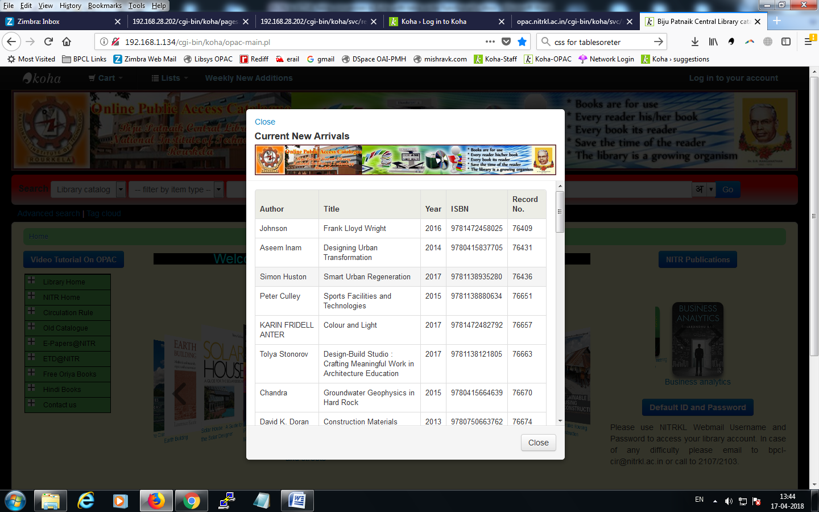
The requirement
We want to display the same report in HTML format but in other separate page i.e. not in Koha OPAC home page so that the entire report can be viewed and analyzed separately like following example: https://rena.mpdl.mpg.de/journals/oagold/ .
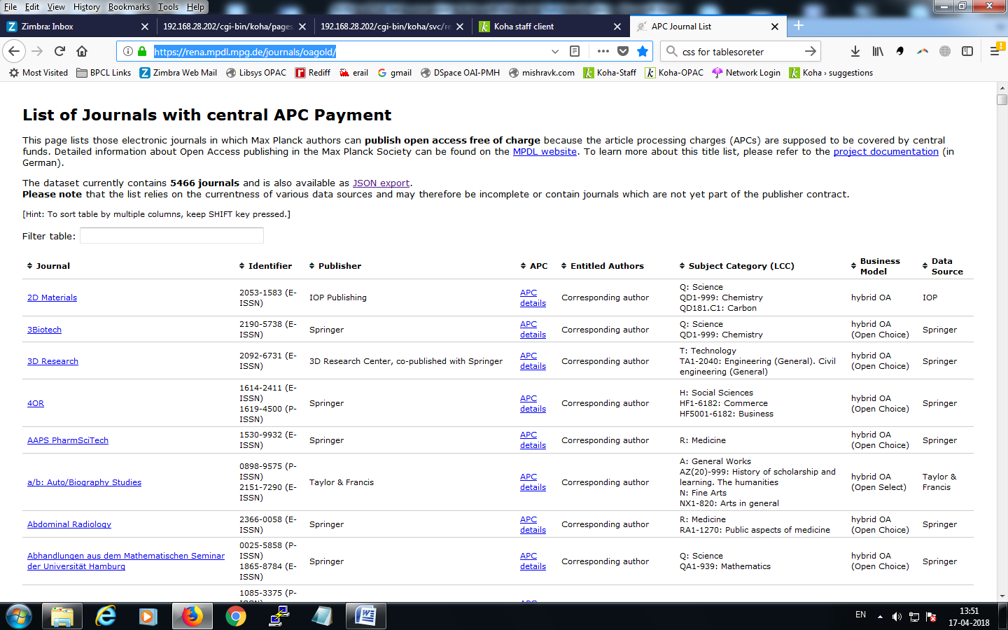
Step by step procedure to display public report in dynamic HTML table format with tablesorter

Step 1
- Make a copy of opac-main.pl page and rename as pages.pl by following command:

cp /usr/share/koha/opac/cgi-bin/opac/opac-main.pl /usr/share/koha/opac/cgi-bin/opac/pages.pl

- Edit pages.pl in an editor and change the code at approx line 34

“template_name => "opac-main.tmpl" to template_name => "pages.tt"

- At approx line number 65 after below code:

$template->param(
koha_news => $all_koha_news,
koha_news_count => $koha_news_count,
display_daily_quote => C4::Context->preference('QuoteOfTheDay'),
daily_quote => $quote,
);

Insert the following code:

my $page = "page_" . $input->param('p'); # go for "p" value in URL and do the concatenation
my $preference = C4::Context->preference($page); # Go for preference
$template->{VARS}->{'page_test'} = $preference; # pass variable to template pages.tt

- Give the Web server user execution permissions to pages.pl file with following command:

$chmod 755 pages.pl

Step 2

- Copy and edit the boostrap theme template i.e. the present home page of OPAC to work like your separate webpage.
Copy /usr/share/koha/opac/htdocs/opac-tmpl/bootstrap/en/modules/opac-main.tt to /usr/share/koha/opac/htdocs/opac-tmpl/bootstrap/en/modules/pages.tt
- At approx line 61 change the following code :
[% IF ( OpacMainUserBlock ) %]<div id="opacmainuserblock">[% OpacMainUserBlock %]</div>[% END %]

To the following code and remove all the code above and below this code:

[% IF ( page_test ) %]<div id="opacmainuserblock">[% page_test %]</div>[% END %]

- Remove all the code from the pages.tt file except the following line to have blank page i.e. not right navigation, left navigation, header area etc. like Koha main OPAC home page.

[% IF ( page_test ) %]<div id="opacmainuserblock">[% page_test %]</div>[% END %]
Step 3
- Now we can make our page called “page_test” with the help of Koha functionality from staff client.
Home › Administration › System Preferences > Local Use and add a New Preference called "page_test"
- Add the following under each head
- Explanation: test page for pages tiny cms
- Variable: page_test
- Value: This is the field where we have to use the HTML/CSS/jQuery etc. to display our dynamic public report with HTML table format. I have used the following code to display our public report (http://opac.nitrkl.ac.in/cgi-bin/koha/svc/report?id=44):

<!-- HTML Current new arrivals -->
<head>
<center><h3>Current New Arrivals</h3></center>
This is list of books just arrived in the library and will be kept in shelving area after technical processing. You may contact to library acquisition section for fast processing of the below books and consultation within the library till final technical processing.
<link rel="stylesheet" href="/opac-tmpl/bootstrap/js/jquery.tablesorter/themes/blue/style.css" type="text/css" media="print, projection, screen" />
<script type="text/javascript" src="/opac-tmpl/bootstrap/js/jquery.tablesorter/jquery-latest.js"></script>
<script type="text/javascript" src="/opac-tmpl/bootstrap/js/jquery.tablesorter/jquery.tablesorter.js"></script>
<script type="text/javascript" src="/opac-tmpl/bootstrap/js/jquery.tablesorter/jquery.tablesorter.min.js"></script>
<script type="text/javascript" src="/opac-tmpl/bootstrap/js/jquery.tablesorter/jquery.metadata.js"></script>
</head>
<center><table id="custom_table" class="tablesorter" cellspacing="1" border="1"></center>
<thead>
<tr>
<th>Author</th>
<th>Title</th>
<th>Year</th>
<th>ISBN</th>
<th>Record No.</th>
</tr>
</thead>
<tbody>
</tbody>
</table>
<!-- HTML Current new arrivals ends -->
<!-- JQuery for display of public report-->
<script>
$(document).ready(function() {
var data1;
$.get( "/cgi-bin/koha/svc/report?id=44", function( data1 ) {
$.each(data1, function(index, value) {
// json is a record arr
var json = value;
var tr;
tr = $('<tr/>');
$.each(json, function(index, value) {
tr.append("<td>" + value + "</td>");
});
$('#custom_table').append(tr); // alert( index + ": " + value );
});
$("#custom_table").tablesorter();
$(function() {
sortMultiSortKey: 'altKey'
});
$(element).wrapInner('<a href="'+$(element).text()+'" target="_blank"></a>');
});
$("#custom_table td:nth-child(4)").each(function(index, element){
});
});
</script>
<!-- JQuery for display of public report end-->

- Click the TextArea link (or enter "TextArea" into the input field below it)
- variable options (last field): 80|50
Step 4
- Adding of table sorter functionality i.e. sorting columns in ascending/descending order. Download the table sorter from http://tablesorter.com/docs/#Download and after extracting the zip file paste the folder (jquery.tablesorter) at /usr/share/koha/opac/htdocs/opac-tmpl/bootstrap/js
The out-put of the above public report which was originally in JSON format (Left pic) has been now converted in dynamic HTML table format (Right pic):
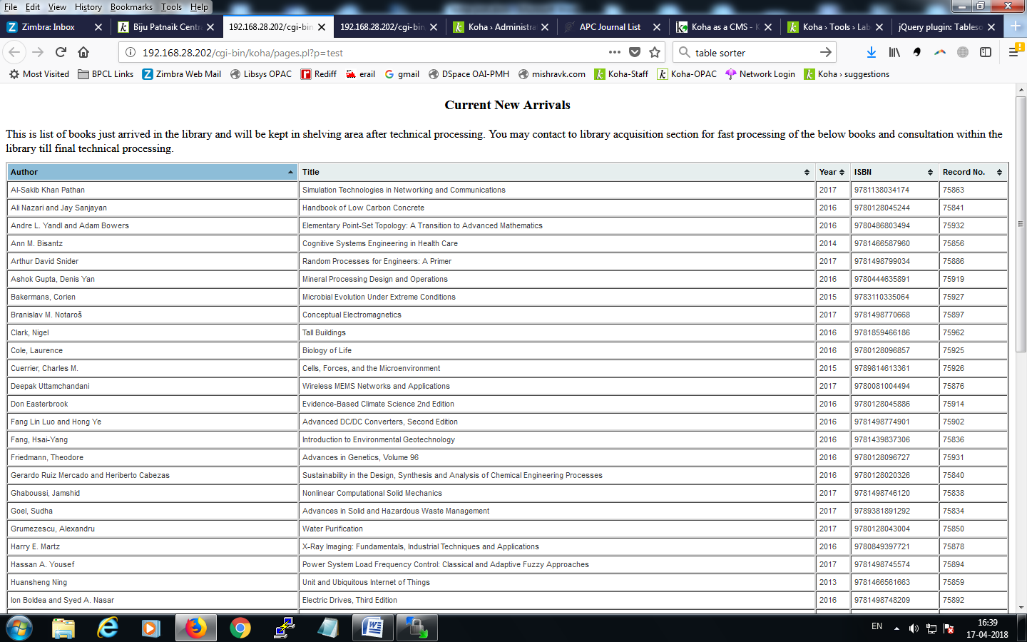

NOTE: Kindly carefully examine the above html/css/jQuery code and make the changes as per your requirements. Please see the URL link parts and make the changes as per your locations of the file in the new page created.

References:
- https://wiki.koha-community.org/wiki/Koha_as_a_CMS
- https://rena.mpdl.mpg.de/journals/oagold/
- http://tablesorter.com/docs/
- http://mishravk.com/2017/05/coverflow-2/
- http://blog.l2c2.co.in/index.php/tag/reports/

