Settings for printing Members Card and Barcode labels (5X13 labels) A4 sheet through Koha, ILMS
- Barcode label setting 65 labels A4 sheet
Barcode label Layout setting
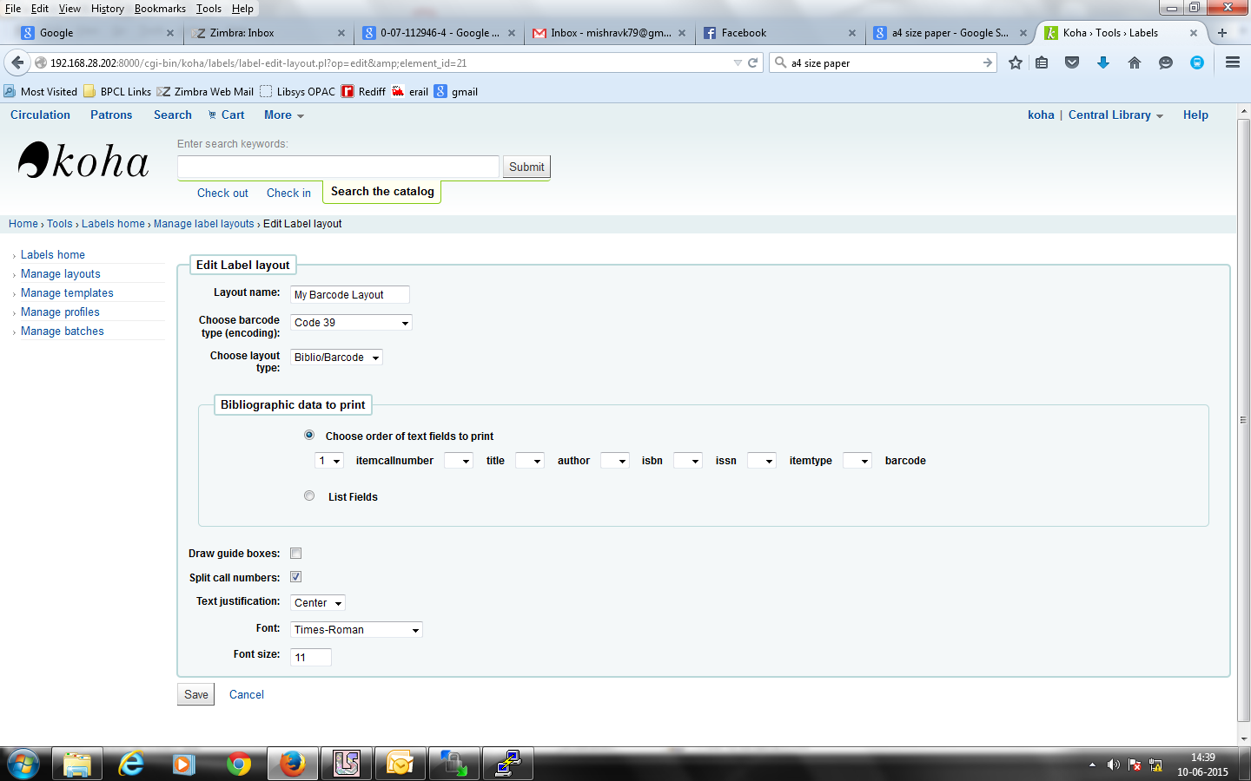
Template setting
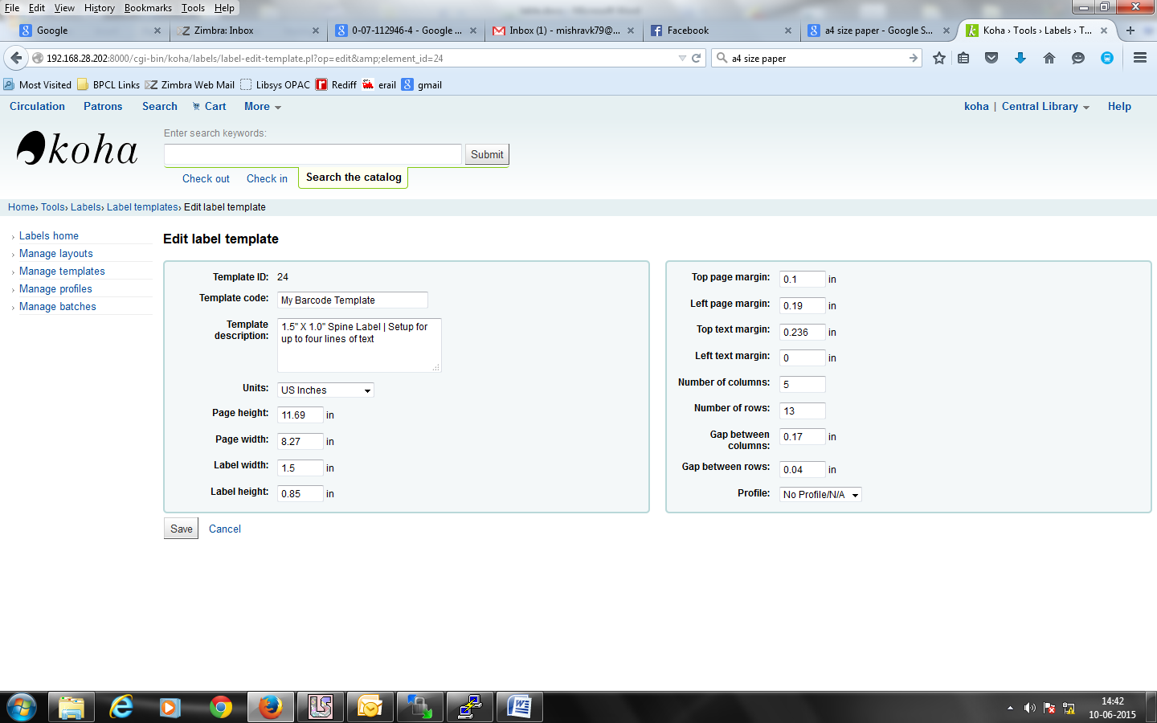
Final Barcode looks like the following:
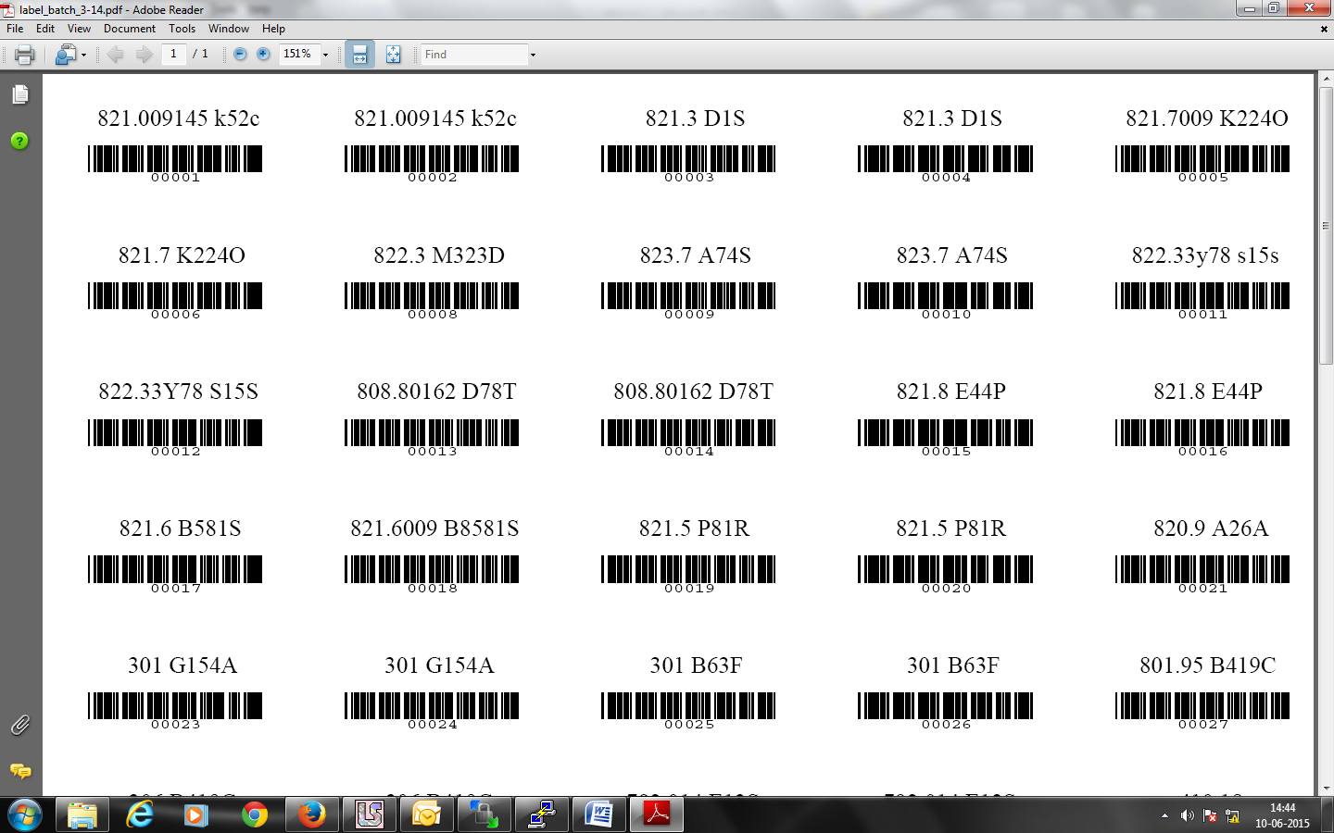

- Member Card setting
Layout format

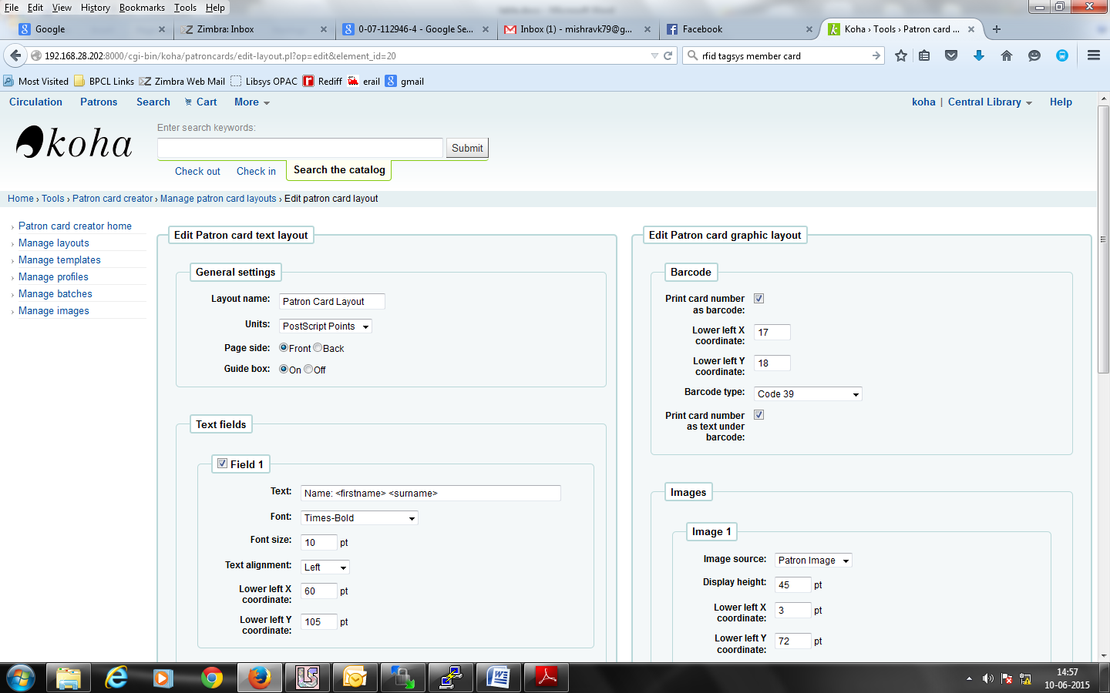
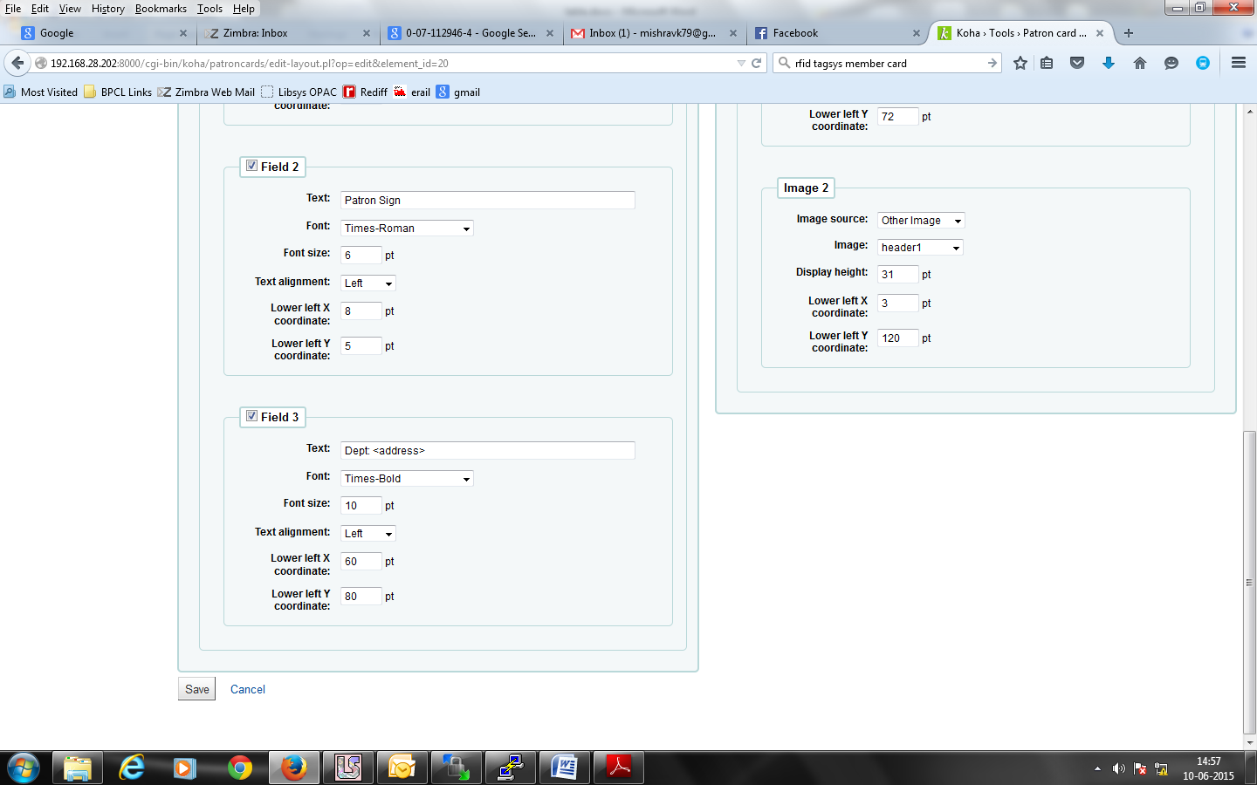

Template setting
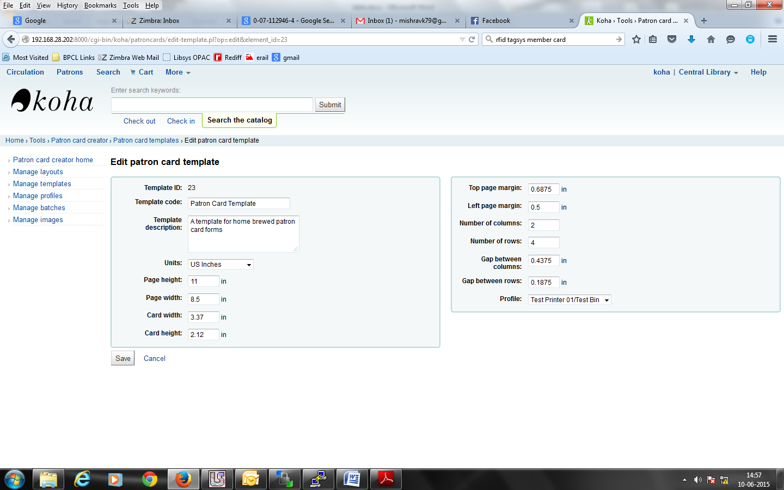
Sample of final Card
